Adarsh Palm Retreat Villas June – November 2021 Water Consumption Report

Bar Plot (Average Water Consumption Per Month):

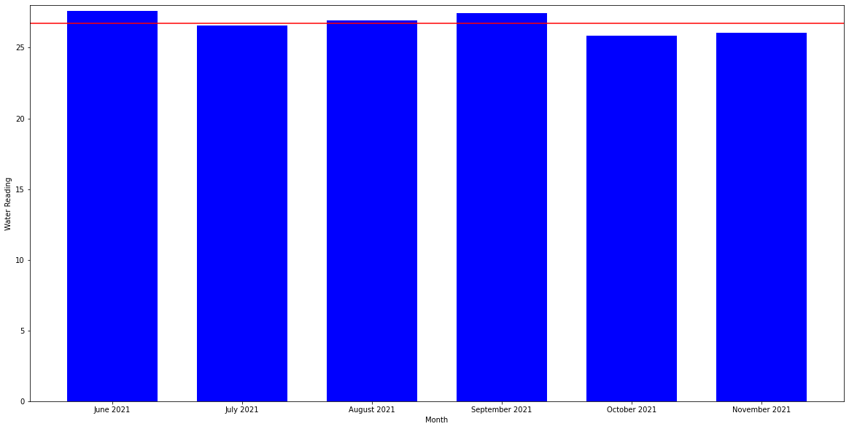

Months Above Average Water Consumption (Red Line = 24.74) of 6 months:

June, August, September

Month with Greatest Average Water Reading: 27.59 🡪 June

Months in Terms of Greatest to Lowest Average Water Reading:

1. June
2. September
3. August
4. July
5. November
6. October

* Note: October might be the lowest due to holiday season

Statistics for Each Month

1. June – 690 Villas

|  |  |  |  |
| --- | --- | --- | --- |
|  | Greater Than Average | Equal to Average | Less Than Average |
| No. of Villas | 298 | 0 | 392 |
| Percentage | 43.19% | 0 | 56.81% |

* Average: 27.59855

1. July – 693 Villas

|  |  |  |  |
| --- | --- | --- | --- |
|  | Greater Than Average | Equal to Average | Less Than Average |
| No. of Villas | 301 | 0 | 392 |
| Percentage | 43.43% | 0 | 56.57% |

* Average: 26.56854
* Decrease in Average from 27.99855 (June) to 26.56954 (July), a decrease of **3.73%**
* Increase by 3 Villas which had a water consumption greater than the Average level
* Increase by **0.24%** in the number of villas greater than the Average level.

1. August – 694 Villas

|  |  |  |  |
| --- | --- | --- | --- |
|  | Greater Than Average | Equal to Average | Less Than Average |
| No. of Villas | 325 | 0 | 369 |
| Percentage | 46.83% | 0 | 53.17% |

* Average: 26.92795
* Increase in Average from 26.56954 (July) to 26.92795 (August), an increase of **1.33%**
* Increase by 24 villas which had a water consumption greater than the Average level.
* Increase by **3.4%** in the number of villas greater than the Average level.

1. September – 697 Villas

|  |  |  |  |
| --- | --- | --- | --- |
|  | Greater Than Average | Equal to Average | Less Than Average |
| No. of Villas | 289 | 0 | 408 |
| Percentage | 41.46% | 0 | 58.54% |

* Average: 27.45767
* Increase in Average from 26.92795 (August) to 27.45767 (September), an increase of **1.97%**
* Decrease by 36 Villas which had a water consumption reading greater than the average level
* Decrease by **5.37%** in the number of villas greater than the average level.
* Villas greater than Average have increase their water consumption level.

1. October – 696 Villas

|  |  |  |  |
| --- | --- | --- | --- |
|  | Greater Than Average | Equal to Average | Less Than Average |
| No. of Villas | 320 | 0 | 376 |
| Percentage | 45.98% | 0 | 54.02% |

* Average: 25.82615
* Decrease in Average from 27.45767 (September) to 25.82615 (October), a decrease of **5.94%**
* Decrease by **4.52%** in the number of villas greater than the average level.
* Increase by 31 Villas which had a water consumption reading greater than the average level

1. November – 697 Villas

|  |  |  |  |
| --- | --- | --- | --- |
|  | Greater Than Average | Equal to Average | Less Than Average |
| No. of Villas | 293 | 0 | 404 |
| Percentage | 43.43% | 0 | 56.57% |

* Average: 26.06169
* Increase in Average from 25.82615 (October) to 26.06169 (November), an increase of **0.91%**.
* Decrease by 27 villas which had a water consumption greater than the Average level.
* Decrease by **2.55%** in the number of villas greater than the average level.
* The villas greater than the average level have increase their water consumption level.

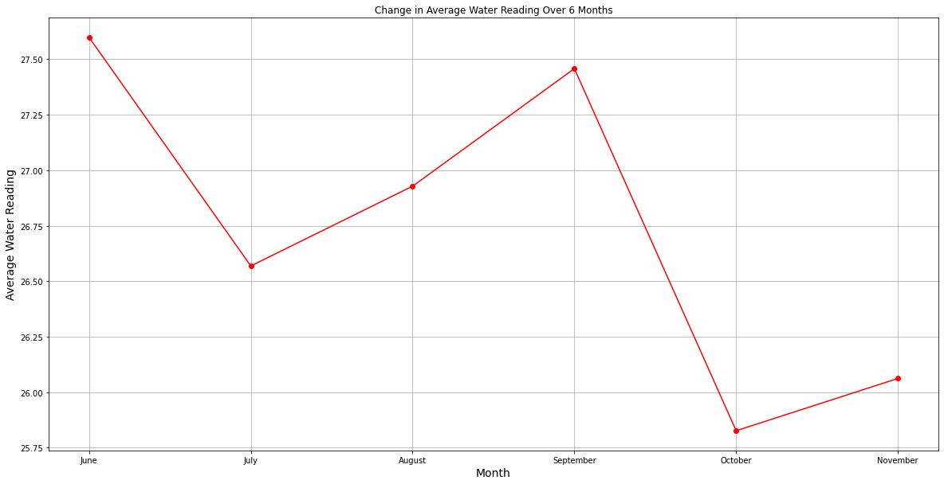

* The above graph is a representation to show the change in average water consumption levels over six months (June – November)
* Greatest increase of Average Water Consumption Level: August to September of **1.97%**.
* Greatest decrease of Average Water Consumption Level: September to October of **5.94%**.

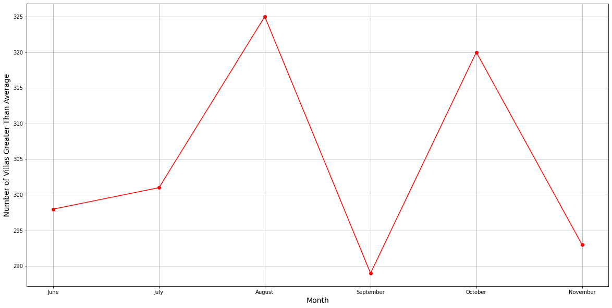

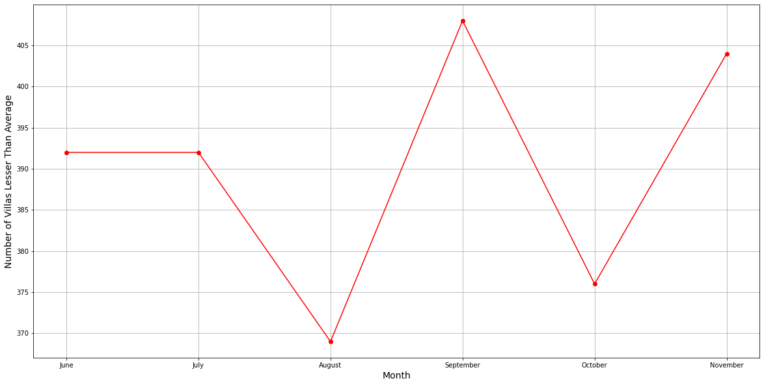

* The first graph is a representation of the change in the number of villas greater than the average over 6 months, and the second is a representation of the change in the number of villas lesser than the average over 6 months.
* Greatest Increase in Number of Villas Greater than the Average: September to October of **31 Villas**
* Greatest Decrease in Number of Villas Greater than the Average: August to September of **36 Villas**
* Greatest Increase in Number of Villas Lesser than Average: August to September of **38 Villas**
* Greatest Decrease in Number of Villas Lesser than Average: September to October of **32 Villas**
* A few specific villas have a really high-water consumption which results in an increase in the total average level.

Top 50 Water Consumers for Each Month:

1. June

+-----------------+---------------------+

| Villa No. Jun | Jun Water Reading |

+=================+=====================+

| 387 | 293 |

+-----------------+---------------------+

| 72 | 153 |

+-----------------+---------------------+

| 37 | 151 |

+-----------------+---------------------+

| 314 | 144 |

+-----------------+---------------------+

| 126 | 114 |

+-----------------+---------------------+

| 379 | 103 |

+-----------------+---------------------+

| 383 | 100 |

+-----------------+---------------------+

| 272 | 99 |

+-----------------+---------------------+

| 157 | 85 |

+-----------------+---------------------+

| 106 | 84 |

+-----------------+---------------------+

| 635 | 80 |

+-----------------+---------------------+

| 415 | 78 |

+-----------------+---------------------+

| 256 | 78 |

+-----------------+---------------------+

| 113 | 78 |

+-----------------+---------------------+

| 697 | 78 |

+-----------------+---------------------+

| 246 | 69 |

+-----------------+---------------------+

| 136 | 68 |

+-----------------+---------------------+

| 128 | 67 |

+-----------------+---------------------+

| 381 | 66 |

+-----------------+---------------------+

| 138 | 66 |

+-----------------+---------------------+

| 191 | 65 |

+-----------------+---------------------+

| 85 | 65 |

+-----------------+---------------------+

| 16 | 65 |

+-----------------+---------------------+

| 321 | 63 |

+-----------------+---------------------+

| 281 | 62 |

+-----------------+---------------------+

| 486 | 61 |

+-----------------+---------------------+

| 302 | 61 |

+-----------------+---------------------+

| 254 | 61 |

+-----------------+---------------------+

| 451 | 59 |

+-----------------+---------------------+

| 709 | 59 |

+-----------------+---------------------+

| 149 | 59 |

+-----------------+---------------------+

| 427 | 58 |

+-----------------+---------------------+

| 160 | 57 |

+-----------------+---------------------+

| 42 | 56 |

+-----------------+---------------------+

| 84 | 55 |

+-----------------+---------------------+

| 264 | 54 |

+-----------------+---------------------+

| 183 | 54 |

+-----------------+---------------------+

| 811 | 54 |

+-----------------+---------------------+

| 423 | 54 |

+-----------------+---------------------+

| 731 | 53 |

+-----------------+---------------------+

| 341 | 53 |

+-----------------+---------------------+

| 432 | 53 |

+-----------------+---------------------+

| 309 | 53 |

+-----------------+---------------------+

| 372 | 52 |

+-----------------+---------------------+

| 36 | 51 |

+-----------------+---------------------+

| 298 | 51 |

+-----------------+---------------------+

| 814 | 51 |

+-----------------+---------------------+

| 165 | 51 |

+-----------------+---------------------+

| 161 | 51 |

+-----------------+---------------------+

| 268 | 50 |

+-----------------+---------------------+

1. July

+-----------------+----------------------+

| Villa No.July | July Water Reading |

+=================+======================+

| 331 | 198 |

+-----------------+----------------------+

| 74 | 173 |

+-----------------+----------------------+

| 141 | 160 |

+-----------------+----------------------+

| 69 | 142 |

+-----------------+----------------------+

| 78 | 130 |

+-----------------+----------------------+

| 37 | 128 |

+-----------------+----------------------+

| 132 | 117 |

+-----------------+----------------------+

| 119 | 101 |

+-----------------+----------------------+

| 108 | 97 |

+-----------------+----------------------+

| 324 | 89 |

+-----------------+----------------------+

| 693 | 88 |

+-----------------+----------------------+

| 468 | 82 |

+-----------------+----------------------+

| 16 | 76 |

+-----------------+----------------------+

| 293 | 71 |

+-----------------+----------------------+

| 171 | 69 |

+-----------------+----------------------+

| 206 | 68 |

+-----------------+----------------------+

| 131 | 67 |

+-----------------+----------------------+

| 643 | 67 |

+-----------------+----------------------+

| 149 | 66 |

+-----------------+----------------------+

| 328 | 65 |

+-----------------+----------------------+

| 222 | 61 |

+-----------------+----------------------+

| 152 | 60 |

+-----------------+----------------------+

| 314 | 60 |

+-----------------+----------------------+

| 85 | 59 |

+-----------------+----------------------+

| 357 | 59 |

+-----------------+----------------------+

| 42 | 59 |

+-----------------+----------------------+

| 47 | 58 |

+-----------------+----------------------+

| 630 | 57 |

+-----------------+----------------------+

| 121 | 56 |

+-----------------+----------------------+

| 392 | 55 |

+-----------------+----------------------+

| 36 | 55 |

+-----------------+----------------------+

| 120 | 55 |

+-----------------+----------------------+

| 274 | 54 |

+-----------------+----------------------+

| 258 | 54 |

+-----------------+----------------------+

| 84 | 54 |

+-----------------+----------------------+

| 424 | 54 |

+-----------------+----------------------+

| 591 | 54 |

+-----------------+----------------------+

| 251 | 53 |

+-----------------+----------------------+

| 11 | 53 |

+-----------------+----------------------+

| 674 | 52 |

+-----------------+----------------------+

| 12 | 52 |

+-----------------+----------------------+

| 173 | 52 |

+-----------------+----------------------+

| 161 | 51 |

+-----------------+----------------------+

| 140 | 51 |

+-----------------+----------------------+

| 365 | 51 |

+-----------------+----------------------+

| 103 | 51 |

+-----------------+----------------------+

| 205 | 50 |

+-----------------+----------------------+

| 374 | 50 |

+-----------------+----------------------+

| 107 | 50 |

+-----------------+----------------------+

| 363 | 49 |

+-----------------+----------------------+

1. August

+-----------------+---------------------+

| Villa No. Aug | Aug Water Reading |

+=================+=====================+

| 147 | 97 |

+-----------------+---------------------+

| 149 | 94 |

+-----------------+---------------------+

| 126 | 86 |

+-----------------+---------------------+

| 107 | 86 |

+-----------------+---------------------+

| 648 | 85 |

+-----------------+---------------------+

| 256 | 79 |

+-----------------+---------------------+

| 138 | 79 |

+-----------------+---------------------+

| 709 | 78 |

+-----------------+---------------------+

| 169 | 76 |

+-----------------+---------------------+

| 373-C | 76 |

+-----------------+---------------------+

| 36 | 74 |

+-----------------+---------------------+

| 272 | 74 |

+-----------------+---------------------+

| 451 | 71 |

+-----------------+---------------------+

| 128 | 71 |

+-----------------+---------------------+

| 148 | 70 |

+-----------------+---------------------+

| 85 | 69 |

+-----------------+---------------------+

| 106 | 68 |

+-----------------+---------------------+

| 12 | 68 |

+-----------------+---------------------+

| 16 | 67 |

+-----------------+---------------------+

| 415 | 67 |

+-----------------+---------------------+

| 84 | 66 |

+-----------------+---------------------+

| 62 | 65 |

+-----------------+---------------------+

| 254 | 64 |

+-----------------+---------------------+

| 176 | 63 |

+-----------------+---------------------+

| 487 | 62 |

+-----------------+---------------------+

| 93 | 60 |

+-----------------+---------------------+

| 89 | 60 |

+-----------------+---------------------+

| 66 | 60 |

+-----------------+---------------------+

| 95 | 58 |

+-----------------+---------------------+

| 69 | 58 |

+-----------------+---------------------+

| 498 | 58 |

+-----------------+---------------------+

| 190 | 58 |

+-----------------+---------------------+

| 281 | 57 |

+-----------------+---------------------+

| 508 | 57 |

+-----------------+---------------------+

| 113 | 57 |

+-----------------+---------------------+

| 120 | 56 |

+-----------------+---------------------+

| 486 | 56 |

+-----------------+---------------------+

| 614 | 56 |

+-----------------+---------------------+

| 46 | 55 |

+-----------------+---------------------+

| 801 | 55 |

+-----------------+---------------------+

| 157 | 55 |

+-----------------+---------------------+

| 161 | 54 |

+-----------------+---------------------+

| 324 | 54 |

+-----------------+---------------------+

| 495 | 54 |

+-----------------+---------------------+

| 383 | 53 |

+-----------------+---------------------+

| 432 | 53 |

+-----------------+---------------------+

| 136 | 53 |

+-----------------+---------------------+

| 657 | 53 |

+-----------------+---------------------+

| 584 | 53 |

+-----------------+---------------------+

| 112 | 52 |

+-----------------+---------------------+

1. September

+-----------------+---------------------+

| Villa No. Sep | Sep Water Reading |

+=================+=====================+

| 814 | 199 |

+-----------------+---------------------+

| 15 | 148 |

+-----------------+---------------------+

| 107 | 106 |

+-----------------+---------------------+

| 147 | 105 |

+-----------------+---------------------+

| 149 | 104 |

+-----------------+---------------------+

| 169 | 92 |

+-----------------+---------------------+

| 148 | 92 |

+-----------------+---------------------+

| 36 | 90 |

+-----------------+---------------------+

| 67 | 87 |

+-----------------+---------------------+

| 126 | 81 |

+-----------------+---------------------+

| 16 | 78 |

+-----------------+---------------------+

| 272 | 77 |

+-----------------+---------------------+

| 256 | 76 |

+-----------------+---------------------+

| 138 | 76 |

+-----------------+---------------------+

| 127 | 75 |

+-----------------+---------------------+

| 373-C | 75 |

+-----------------+---------------------+

| 498 | 74 |

+-----------------+---------------------+

| 85 | 68 |

+-----------------+---------------------+

| 415 | 66 |

+-----------------+---------------------+

| 128 | 63 |

+-----------------+---------------------+

| 451 | 62 |

+-----------------+---------------------+

| 383 | 62 |

+-----------------+---------------------+

| 326 | 61 |

+-----------------+---------------------+

| 624 | 60 |

+-----------------+---------------------+

| 709 | 59 |

+-----------------+---------------------+

| 684 | 58 |

+-----------------+---------------------+

| 160 | 57 |

+-----------------+---------------------+

| 95 | 57 |

+-----------------+---------------------+

| 157 | 57 |

+-----------------+---------------------+

| 62 | 56 |

+-----------------+---------------------+

| 12 | 56 |

+-----------------+---------------------+

| 487 | 56 |

+-----------------+---------------------+

| 254 | 56 |

+-----------------+---------------------+

| 113 | 56 |

+-----------------+---------------------+

| 378 | 55 |

+-----------------+---------------------+

| 106 | 55 |

+-----------------+---------------------+

| 190 | 55 |

+-----------------+---------------------+

| 495 | 55 |

+-----------------+---------------------+

| 161 | 54 |

+-----------------+---------------------+

| 584 | 54 |

+-----------------+---------------------+

| 699 | 54 |

+-----------------+---------------------+

| 653 | 54 |

+-----------------+---------------------+

| 486 | 54 |

+-----------------+---------------------+

| 703 | 53 |

+-----------------+---------------------+

| 324 | 53 |

+-----------------+---------------------+

| 669 | 53 |

+-----------------+---------------------+

| 697 | 52 |

+-----------------+---------------------+

| 192 | 52 |

+-----------------+---------------------+

| 84 | 51 |

+-----------------+---------------------+

| 8 | 51 |

+-----------------+---------------------+

1. October

+-----------------+---------------------+

| Villa No. Oct | Oct Water Reading |

+=================+=====================+

| 149 | 171 |

+-----------------+---------------------+

| 96 | 129 |

+-----------------+---------------------+

| 709 | 113 |

+-----------------+---------------------+

| 355 | 104 |

+-----------------+---------------------+

| 169 | 81 |

+-----------------+---------------------+

| 147 | 80 |

+-----------------+---------------------+

| 126 | 79 |

+-----------------+---------------------+

| 16 | 77 |

+-----------------+---------------------+

| 373-C | 77 |

+-----------------+---------------------+

| 107 | 73 |

+-----------------+---------------------+

| 138 | 69 |

+-----------------+---------------------+

| 36 | 69 |

+-----------------+---------------------+

| 415 | 68 |

+-----------------+---------------------+

| 113 | 67 |

+-----------------+---------------------+

| 85 | 66 |

+-----------------+---------------------+

| 84 | 65 |

+-----------------+---------------------+

| 272 | 63 |

+-----------------+---------------------+

| 190 | 61 |

+-----------------+---------------------+

| 383 | 60 |

+-----------------+---------------------+

| 498 | 60 |

+-----------------+---------------------+

| 735 | 60 |

+-----------------+---------------------+

| 703 | 58 |

+-----------------+---------------------+

| 453 | 57 |

+-----------------+---------------------+

| 533 | 56 |

+-----------------+---------------------+

| 298 | 56 |

+-----------------+---------------------+

| 699 | 56 |

+-----------------+---------------------+

| 487 | 55 |

+-----------------+---------------------+

| 495 | 54 |

+-----------------+---------------------+

| 12 | 54 |

+-----------------+---------------------+

| 127 | 53 |

+-----------------+---------------------+

| 697 | 53 |

+-----------------+---------------------+

| 160 | 53 |

+-----------------+---------------------+

| 95 | 53 |

+-----------------+---------------------+

| 423 | 53 |

+-----------------+---------------------+

| 106 | 52 |

+-----------------+---------------------+

| 324 | 52 |

+-----------------+---------------------+

| 486 | 52 |

+-----------------+---------------------+

| 45 | 51 |

+-----------------+---------------------+

| 451 | 51 |

+-----------------+---------------------+

| 79 | 51 |

+-----------------+---------------------+

| 128 | 50 |

+-----------------+---------------------+

| 596 | 50 |

+-----------------+---------------------+

| 536 | 50 |

+-----------------+---------------------+

| 378 | 50 |

+-----------------+---------------------+

| 256 | 50 |

+-----------------+---------------------+

| 42 | 49 |

+-----------------+---------------------+

| 624 | 49 |

+-----------------+---------------------+

| 309 | 49 |

+-----------------+---------------------+

| 69 | 48 |

+-----------------+---------------------+

| 120 | 48 |

+-----------------+---------------------+

1. November

+-----------------+---------------------+

| Villa No. Nov | Nov Water Reading |

+=================+=====================+

| 169 | 93 |

+-----------------+---------------------+

| 126 | 92 |

+-----------------+---------------------+

| 752 | 91 |

+-----------------+---------------------+

| 149 | 84 |

+-----------------+---------------------+

| 371 | 81 |

+-----------------+---------------------+

| 127 | 80 |

+-----------------+---------------------+

| 709 | 78 |

+-----------------+---------------------+

| 16 | 78 |

+-----------------+---------------------+

| 272 | 77 |

+-----------------+---------------------+

| 387 | 77 |

+-----------------+---------------------+

| 84 | 76 |

+-----------------+---------------------+

| 185 | 75 |

+-----------------+---------------------+

| 415 | 73 |

+-----------------+---------------------+

| 147 | 69 |

+-----------------+---------------------+

| 138 | 65 |

+-----------------+---------------------+

| 85 | 65 |

+-----------------+---------------------+

| 107 | 63 |

+-----------------+---------------------+

| 113 | 61 |

+-----------------+---------------------+

| 364 | 60 |

+-----------------+---------------------+

| 533 | 60 |

+-----------------+---------------------+

| 699 | 59 |

+-----------------+---------------------+

| 74 | 58 |

+-----------------+---------------------+

| 584 | 58 |

+-----------------+---------------------+

| 36 | 58 |

+-----------------+---------------------+

| 106 | 58 |

+-----------------+---------------------+

| 20 | 58 |

+-----------------+---------------------+

| 120 | 57 |

+-----------------+---------------------+

| 160 | 57 |

+-----------------+---------------------+

| 190 | 56 |

+-----------------+---------------------+

| 378 | 55 |

+-----------------+---------------------+

| 128 | 55 |

+-----------------+---------------------+

| 246 | 54 |

+-----------------+---------------------+

| 703 | 54 |

+-----------------+---------------------+

| 373-C | 53 |

+-----------------+---------------------+

| 383 | 53 |

+-----------------+---------------------+

| 256 | 52 |

+-----------------+---------------------+

| 498 | 52 |

+-----------------+---------------------+

| 486 | 51 |

+-----------------+---------------------+

| 42 | 51 |

+-----------------+---------------------+

| 312 | 50 |

+-----------------+---------------------+

| 487 | 50 |

+-----------------+---------------------+

| 172 | 50 |

+-----------------+---------------------+

| 789 | 50 |

+-----------------+---------------------+

| 423 | 50 |

+-----------------+---------------------+

| 69 | 50 |

+-----------------+---------------------+

| 614 | 50 |

+-----------------+---------------------+

| 495 | 50 |

+-----------------+---------------------+

| 45 | 50 |

+-----------------+---------------------+

| 582 | 49 |

+-----------------+---------------------+

| 607 | 49 |

+-----------------+---------------------+